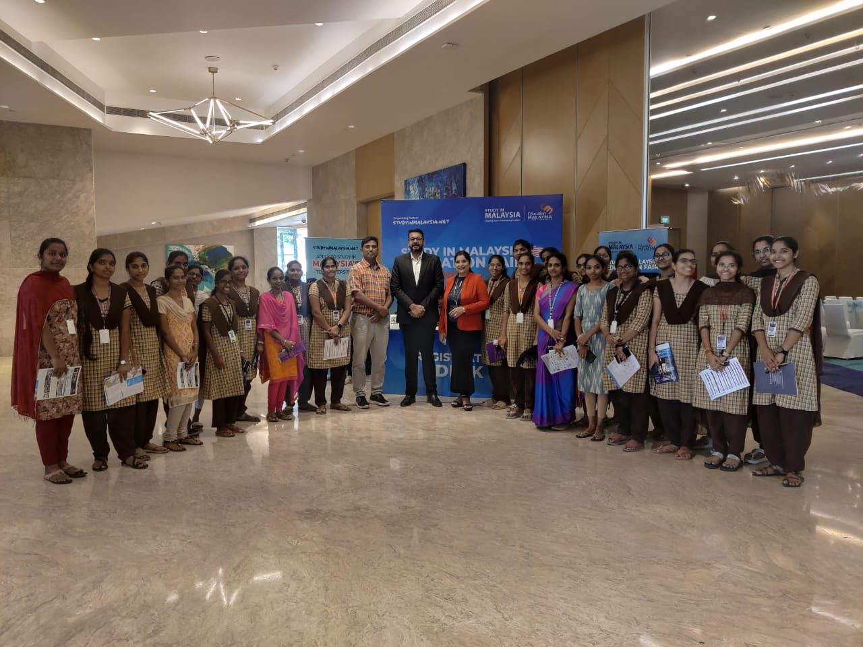
Our students interaction at Malaysia Education fair, Novatel, Vijayawada on 20-02-2024
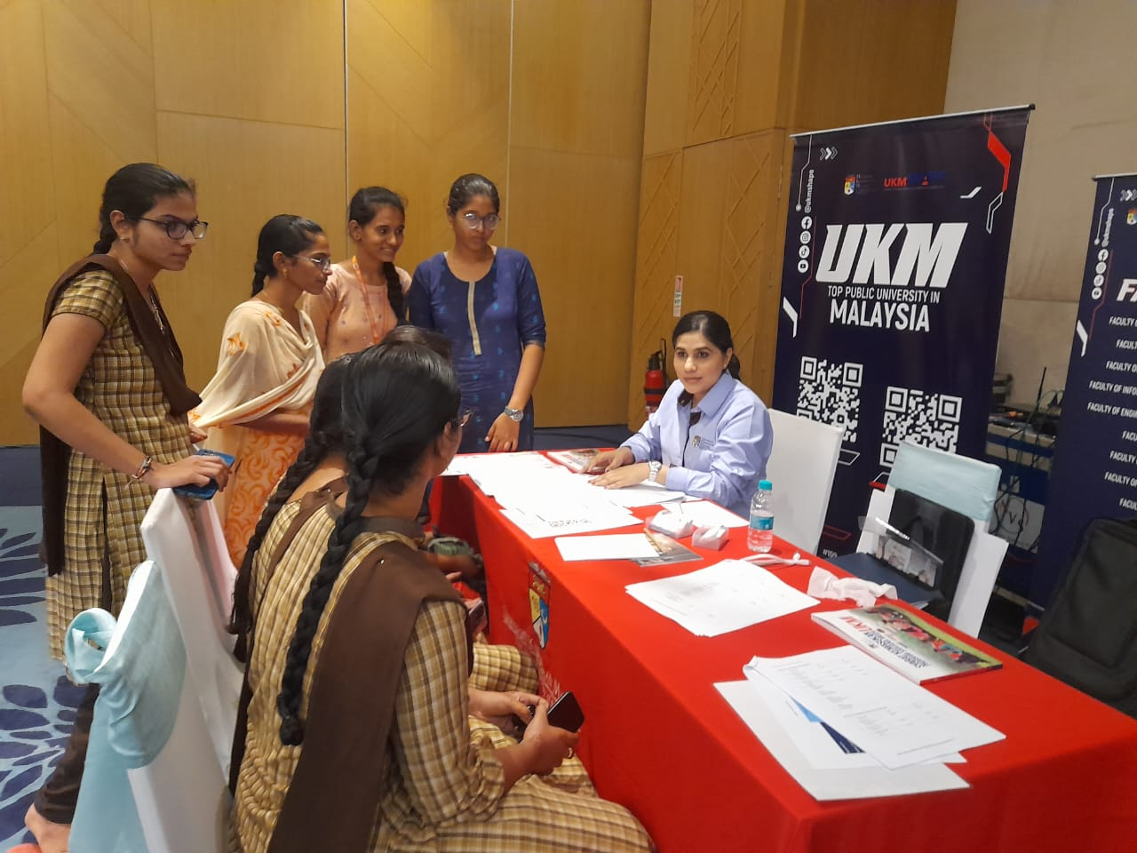
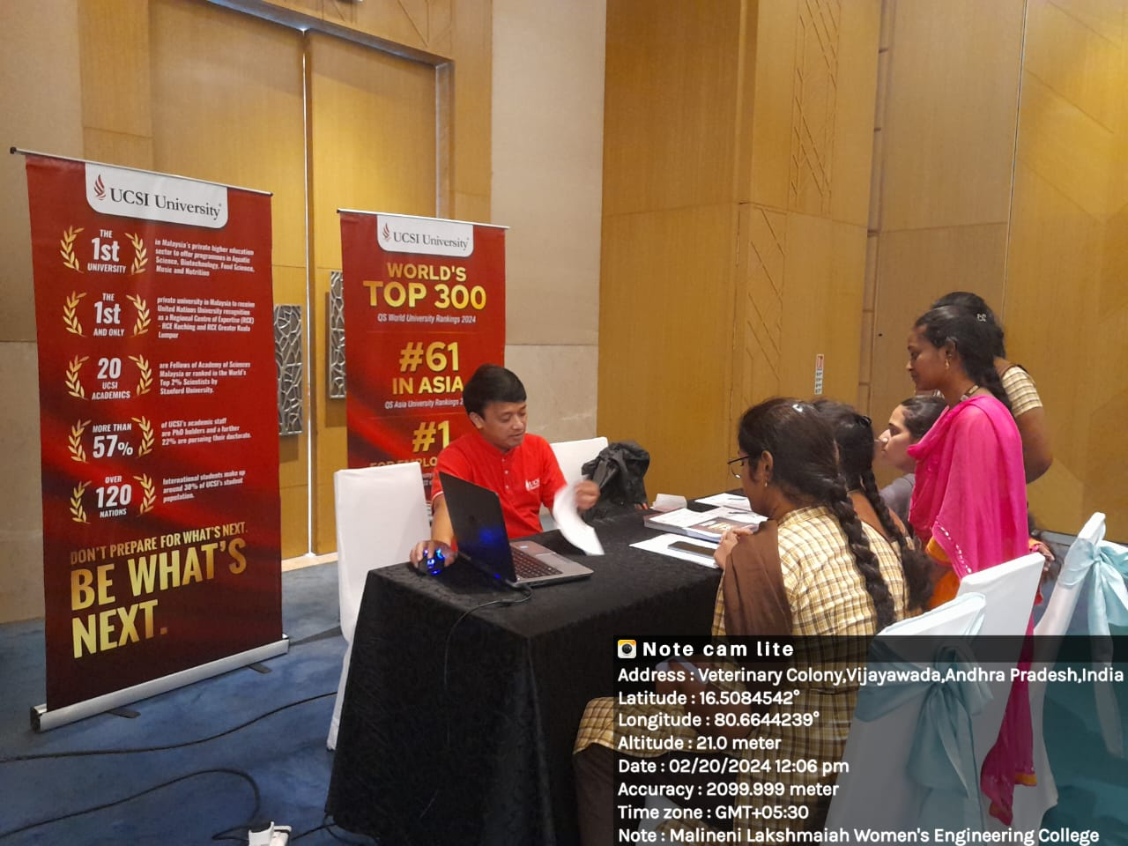
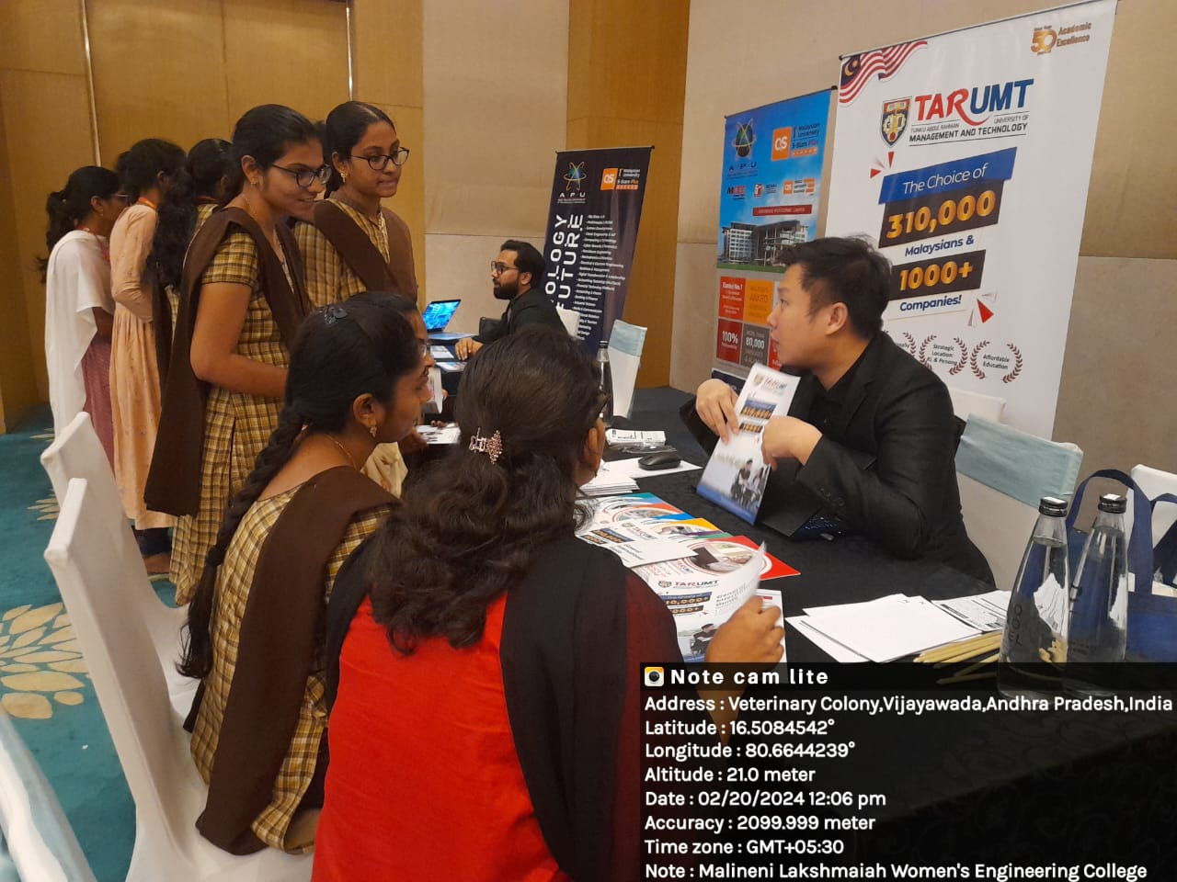
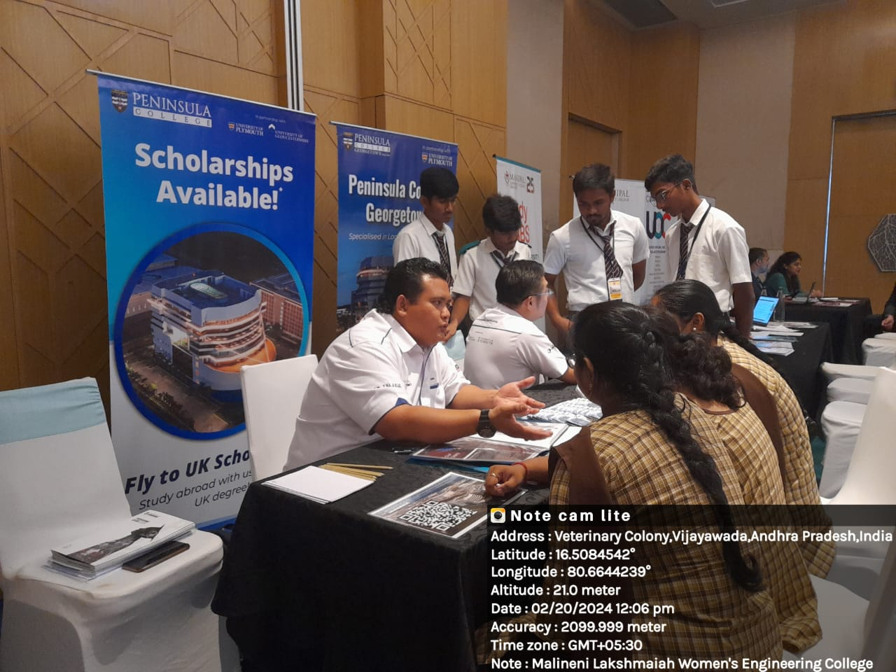
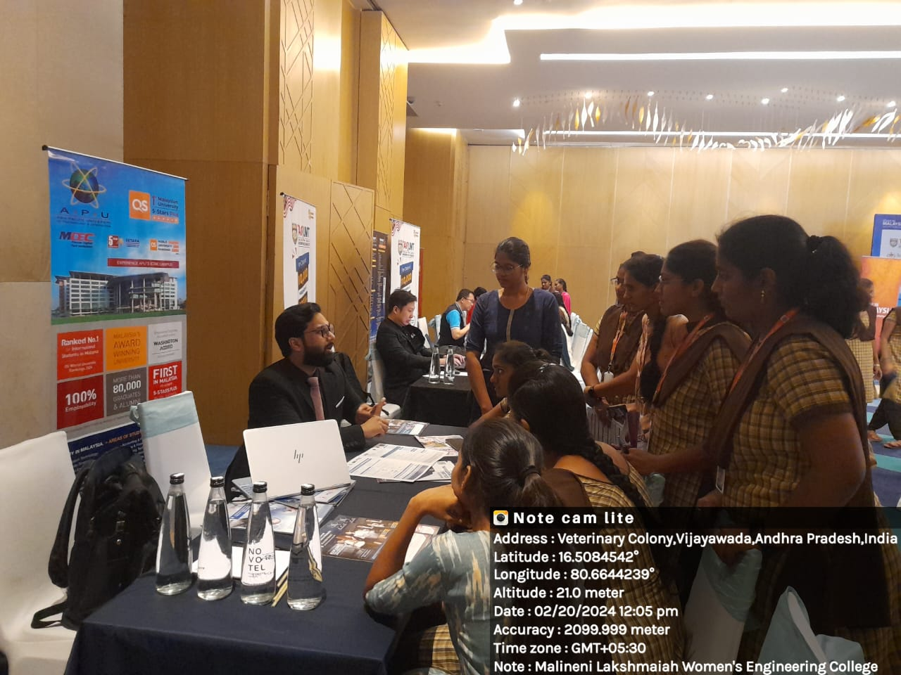

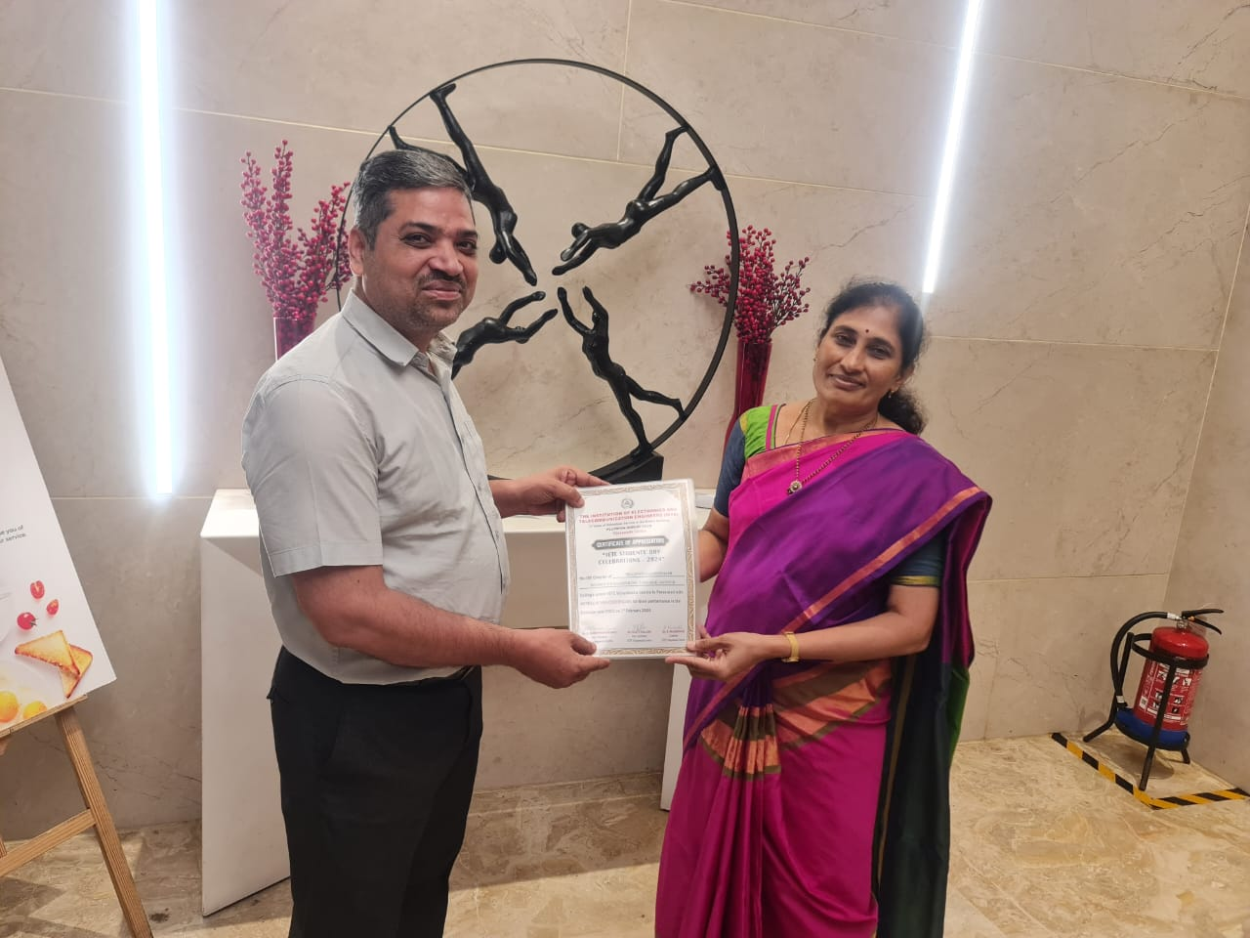
Certificate of Appreciation to MLEW- ISF from IETE,Delhi given by IETE charman Dr.Rajasekhar,Vijayawada chapter
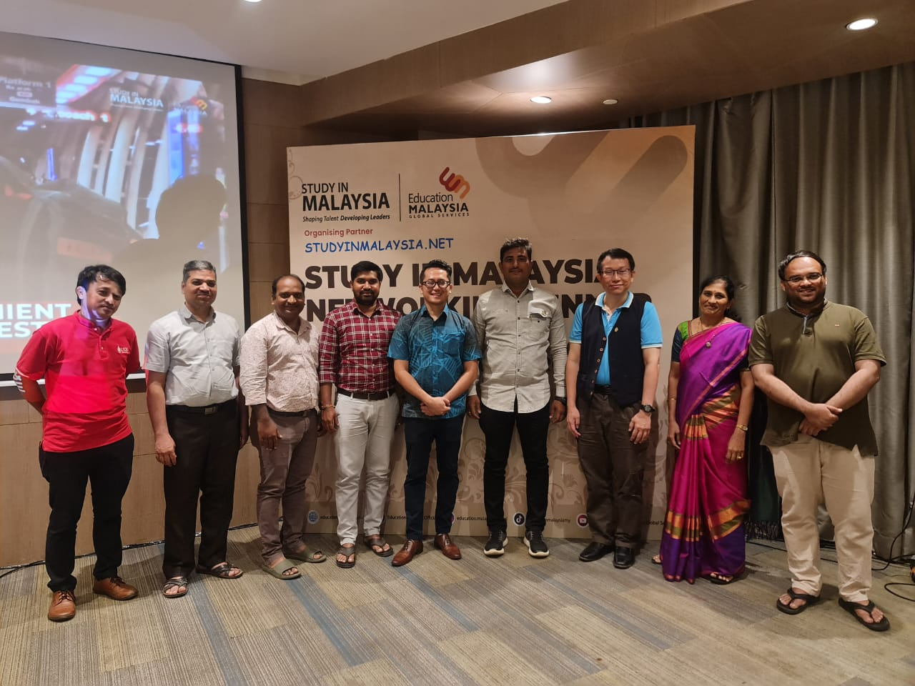
MlEW faculty with Malaysia Education minister Mr.Raja fariq on 19-02-2024

